
a
Company
Logotype

Cone Beam Computed Tomography- Report



Porur Dental X-rays & CBCT

Patient Name : Mr. Markandeyulu | Date of Report : 20.04.2024
Age/ Gender : 59 years/ Male | Region of Interest : CBCT Sectional Maxilla
Referring doctor: Dr. Nethaji | Indication : Implant assessment
Clinical Notes: Nil
PATIENT INFORMATION

CBCT- Sectional Maxilla provided
CBCT – IMAGE DETAILS

RADIOGRAPHIC INTERPRETATION

- Completely missing crown and root portion in relation to: 13.
- Fractured crown in relation to 12, 14.
- Hyperdense crown structure evident in relation to 15, 16, 17.
- Presence of hyperdense restorative material within the pulp canal of 12, 24.
- The maxillary alveolar ridge is present with normal trabecular pattern.
 | 12 region | 13 region | 14 region
Sub-Crestal (in mm) | 4.74 | 8.75 | 10.38
Mid- Crestal (in mm) | 4.54 | 7.81 | 9.51
Distance between the alveolar ridge and floor of the nasal cavity (in mm) | 15.22 | 21.61 | 13.59
 | 15 region | 16 region | 17 region
Sub-Crestal (in mm) | 10.46 | - | -
Mid- Crestal (in mm) | 11.51 | - | -
Distance between the alveolar ridge and floor of the maxillary sinus (in mm) | 10.62 | 2.84 | 7.16
IMPLANT ASSESSMENT

RADIOGRAPHIC IMPRESSION

- Partially edentulous maxillary arch.
- Fractured crown: 12, 14.
- Crown in relation to 15, 16, 17.

Kindly correlate with clinical findings


IMAGES FOR REFERENCE

RECONSTRUCTED PANORAMIC VIEW
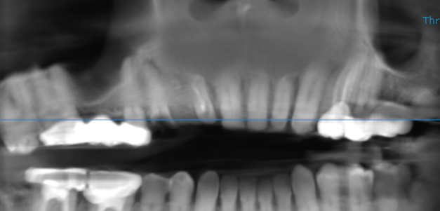

3-DIMENSIONAL VIEW

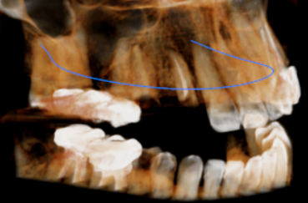

CROSS SECTIONAL VIEW

12 region | 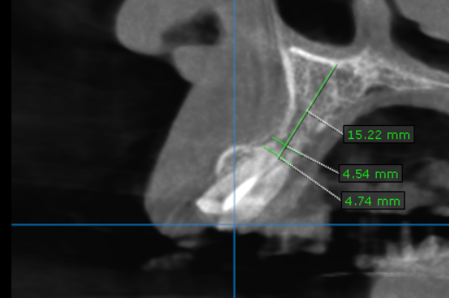
13 region | 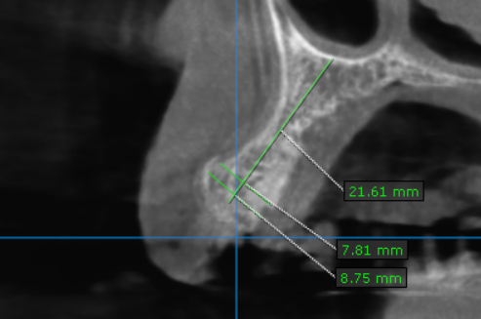
14 region | 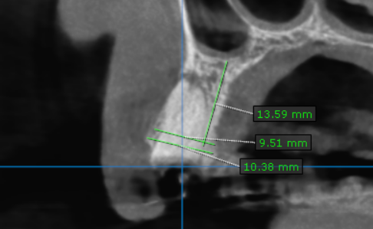
15 region | 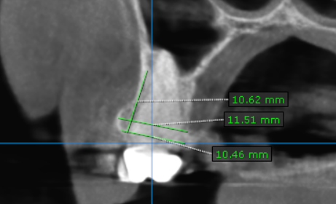
16 region | 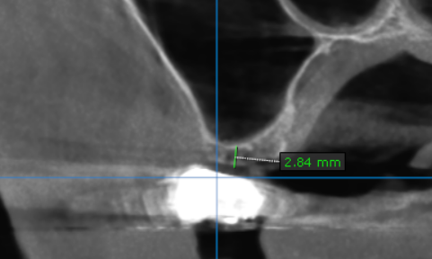
17 region | 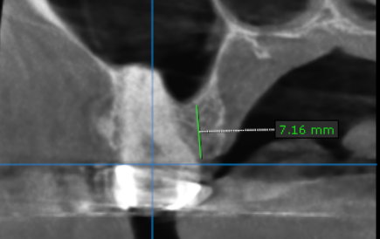

**** End of report ****

